*Name : Insha Mulla*

*Batch : June 2021*

**Task 1 Report**

**AIM :***To solve 5 labs on Portswigger.*

**URL :***https://portswigger.net*

**DESCRIPTION :**

* Labs Solved :

1. Reflected XSS into HTML context with nothing encoded.
2. DOM XSS in document.write sink using source location.search.
3. DOM XSS in innerHTML sink using source location.search.
4. DOM XSS in jQuery anchor href attribute sink using location.search source.
5. DOM XSS in AngularJS expression with angle brackets and double quotes HTML-encoded.

**CONCLUSION :** Solved hands on labs and learnt about new vulnerabilities.

**SNAPSHOTS :**

* START:

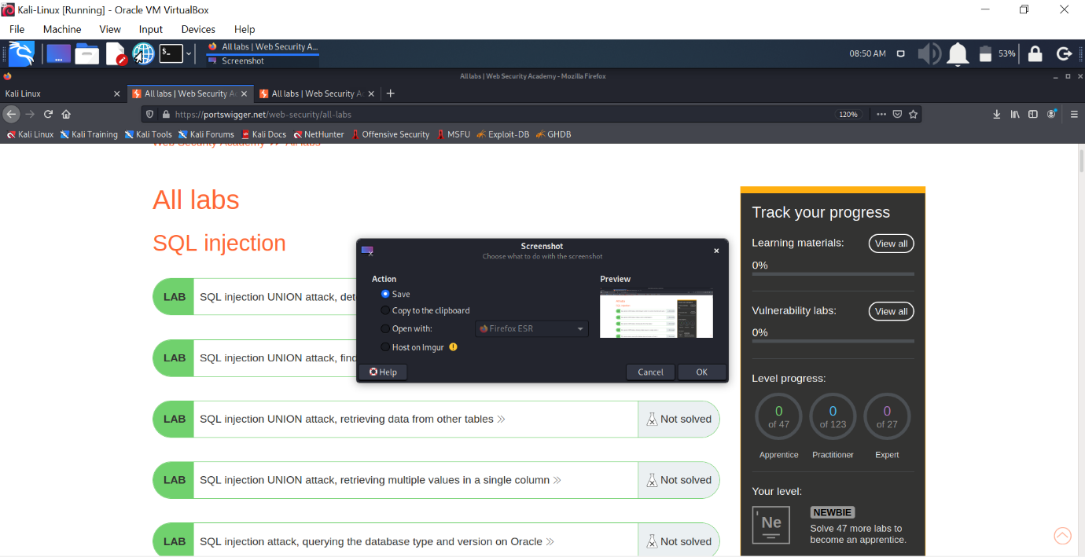

* LAB 1 : Reflected XSS into HTML context with nothing encoded.

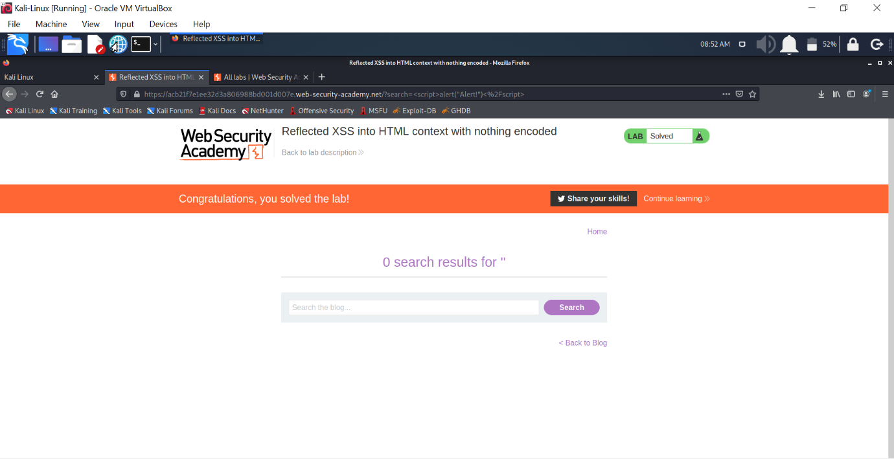

* LAB 2 : DOM XSS in document.write sink using source location.search.

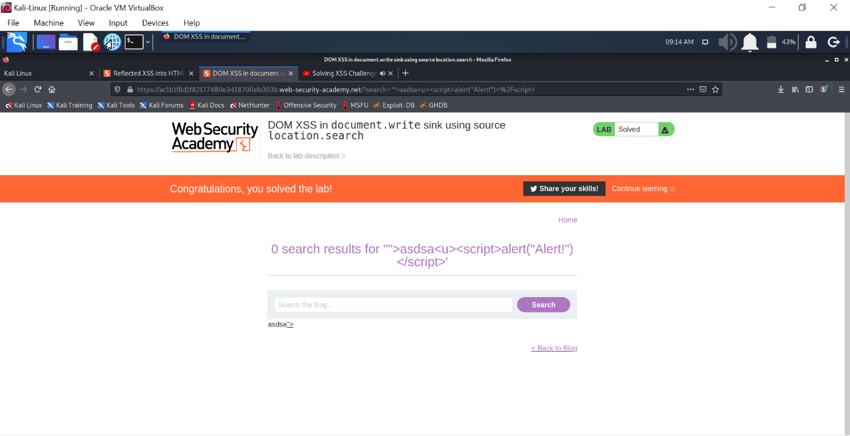

* LAB 3 : DOM XSS in innerHTML sink using source location.search.

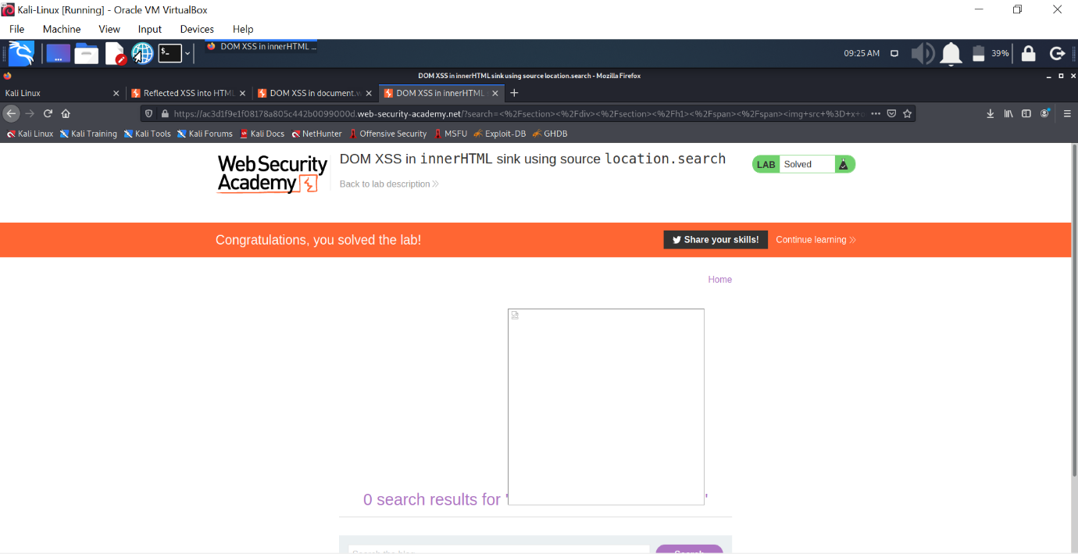

* LAB 4 : DOM XSS in jQuery anchor href attribute sink using location.search source.

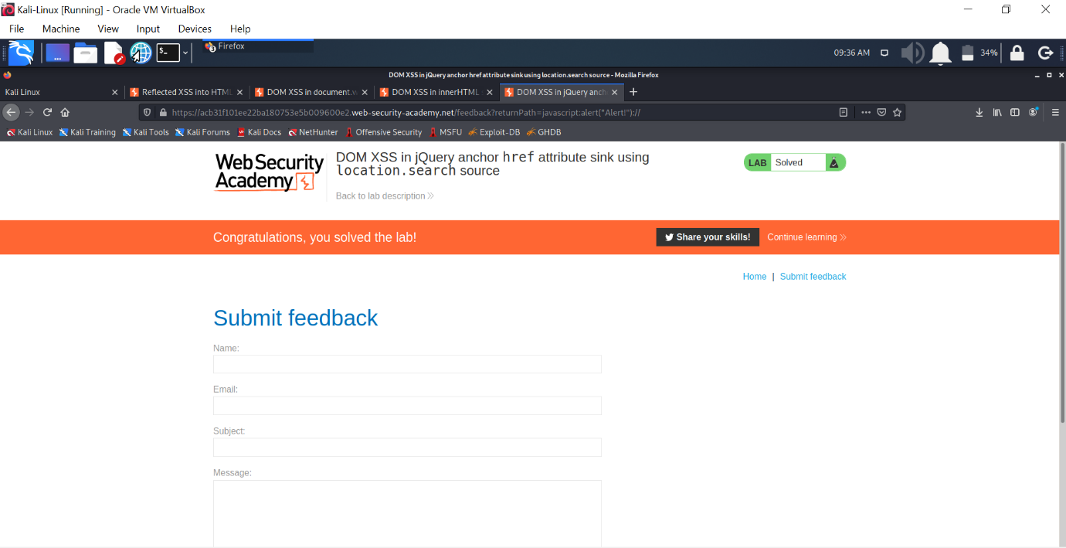

* LAB 5 : DOM XSS in AngularJS expression with angle brackets and double quotes HTML-encoded.

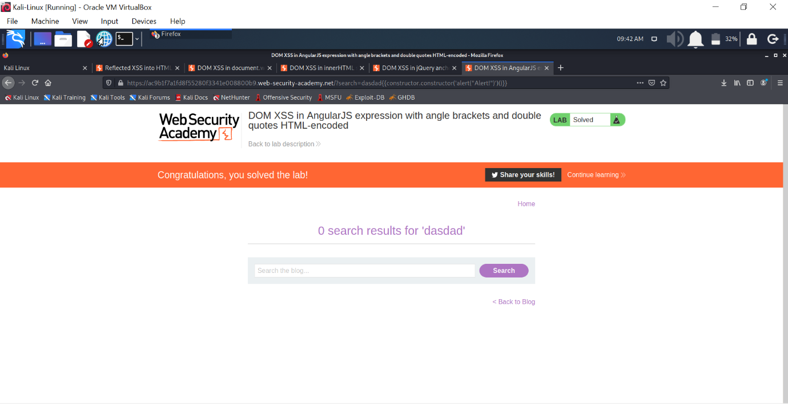

* END :

